# 📘 My English Hub

**English In Company – Enhance your staff with useful tools. Intermediate Level**

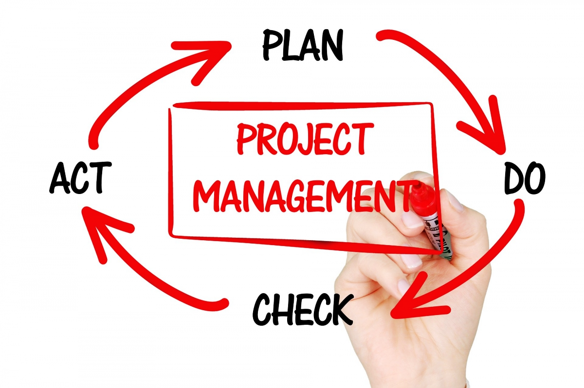**Profession Focus**

#### **What Does a Project Manager Do?**

**Hello you!** We’re back with our conversations about the world of work.

Today, we’re focusing on the person responsible for planning, executing, and overseeing projects — making sure everything is done on time, within scope, and within budget. They coordinate with internal teams and external stakeholders, manage resources, and maintain clear communication throughout the project lifecycle. Their role is pivotal in aligning project objectives with organizational goals and ensuring successful project delivery.

Are they a magician? A juggler? Or maybe a bit of both?

Let’s find out what a **Project Manager** really does — and how to talk about it in everyday English.

#### **Common Vocabulary**

| **Term** | **Definition** |
| --- | --- |
| **Milestone** | A significant point or event in the project timeline. |
| **Stakeholder** | Individuals or groups affected by or involved in the project. |
| **Deliverable** | A tangible or intangible output produced as a result of project activities. |
| **Scope** | The boundaries and extent of the project work. |
| **Timeline** | The schedule outlining project phases and deadlines. |
| **Kick-off Meeting** | The initial meeting to discuss project objectives and plans. |
| **Resource Allocation** | Distribution of resources across project tasks. |
| **Deadline** | The latest time by which a task or project must be completed. |
| **Update** | A report or communication detailing project progress. |
| **Risk Management** | The process of identifying and mitigating potential project issues. |



#### 🧾 Match: **Key Responsibilities**

1. 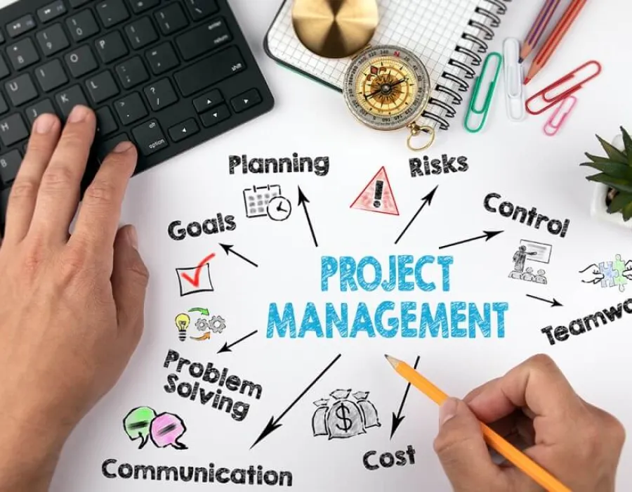**Define Project Scope and Objectives**
2. **Develop Detailed Project Plans**
3. **Coordinate Internal and External Resources**
4. **Monitor Project Progress**
5. **Communicate and report**
6. **Ensure Quality Standards**
7. **Drive Continuous Improvement**
8. Identify areas for process enhancement and implement strategies for better project outcomes.
9. Provide regular updates, address concerns, and facilitate effective communication channels.
10. Ensure all parties are aligned and resources are utilized efficiently.
11. Establish clear project goals and deliverables in collaboration with stakeholders.
12. Create comprehensive plans outlining timelines, resource allocation, and budget considerations.
13. Track milestones, manage risks, and implement necessary adjustments to stay on course.
14. Uphold organizational policies and industry best practices throughout the project lifecycle.

#### 

#### Answers: 1d - 2e - 3c - 4f - 5b - 6g - 7a

#### 🗣️ **Sample Dialogues**

**1. Kick-off Meeting Introduction**

**Project Manager:** "Good morning, team. Today, we commence the new product launch project. Let's review our timeline and establish key milestones."

**Team Member:** "Do we have a confirmed final deadline?"

**Project Manager:** "Yes, our target launch date is July 1st, giving us three months to complete development, testing, and deployment."

**2. Providing a Status Update**

**Client:** "Could you provide an update on the project's current status?"

**Project Manager:** "Certainly. We're on schedule. Development is 80% complete, and we're preparing for the testing phase next week."

**Client:** "Are there any potential risks we should be aware of?"

**Project Manager:** "There's a minor delay with one supplier, but we've adjusted our timeline to mitigate any significant impact."

**3. Delegating Tasks in a Meeting**

**Project Manager:** "Sara, please handle the client presentations. Mark, I need you to oversee the risk assessment."

**Sara:** "Understood. When is the first client meeting scheduled?"

**Project Manager:** "It's set for Thursday morning. I'll share the agenda later today."

There are other ways to call someone who participates in a project:

| **Term** | **Nuance** |
| --- | --- |

|  |  |
| --- | --- |
| **Team member** | Someone actively working on the project (internal role) |

|  |  |
| --- | --- |
| **Project participant** | A broader and more neutral term, used in casual or inclusive contexts |

|  |  |
| --- | --- |
| **Contributor** | Someone who adds value, usually by completing tasks or offering expertise |

|  |  |
| --- | --- |
| **Decision-maker** | Someone with authority over project direction (often part of senior management) |

|  |  |
| --- | --- |
| **Client** | The person or organization the project is being done for |

|  |  |
| --- | --- |
| **Sponsor** | A senior person who champions and funds the project internally |

|  |  |
| --- | --- |
| **End-user** | The final person who will use the product/service the project delivers |

|  |  |
| --- | --- |
| **Partner** | External collaborators, often from another company or department |

|  |  |
| --- | --- |
| **Interested party** | More general and often used in compliance or legal language |

### 🧩 Practice

*Task 1: Match each task to what a Project Manager might say.*

| **Responsibility** | **What the PM says** |
| --- | --- |
| A. Set a deadline | 1. "There’s a delay with the supplier, any ideas?" |
| B. Assign tasks | 2. "So far, we’re on track and 70% complete." |
| C. Give a project update | 3. "We need to finish this phase by next Friday." |
| D. Organize a team meeting | 4. "Let’s meet tomorrow at 10 a.m. to plan the week." |
| E. Identify a problem | 5. "Carla, could you take care of the budget review?" |

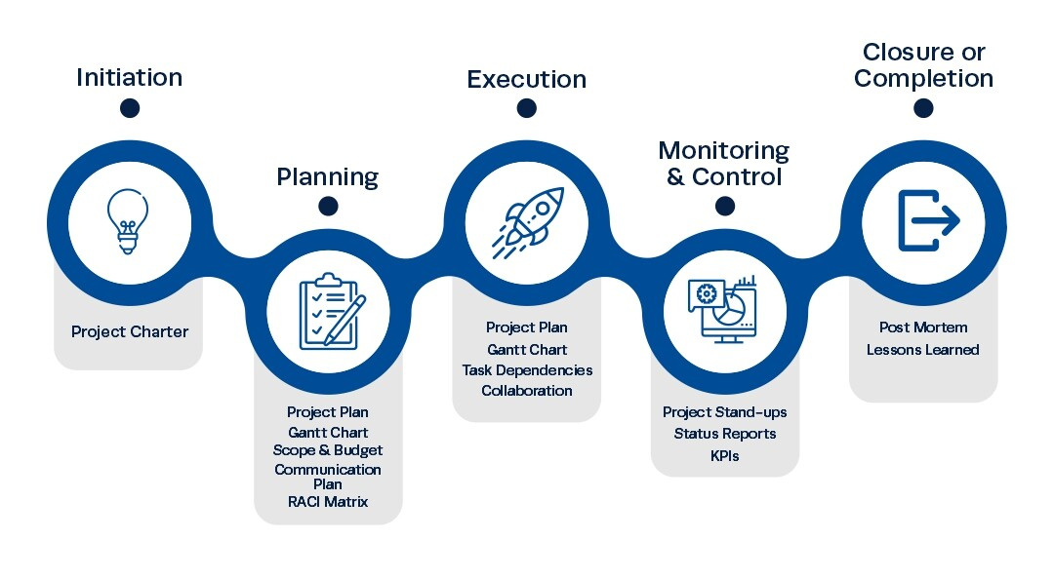

#### 🗣️ Task 2: Complete the dialogue:

slides - draft - deadlines - Monday - update - John

**PM:** Hi everyone, thanks for joining. Let’s go over the 1)_______ for this week.  
**Team Member:** Sure! Do we have any 2) __________ coming up?  
**PM:** Yes, we need to finish the 3)________ by 4)_______.  
**Team Member:** Got it. Who’s doing the presentation?  
**PM:** 5)_______ will handle it. I’ll send the 6)__________ later today.

#### 💬 Task 3: Match Formal vs Informal.

| **Formal / Business Phrase** | **Everyday English** |
| --- | --- |
| 1.We need to allocate resources wisely. | A. We changed the schedule because of some problems. |
| 2.The timeline has been adjusted due to unforeseen issues. | B. Can you tell me how it’s going? |
| 3.Please provide an update on your progress. | C. We need to use our time and tools well. |

**Where Can a Project Manager Work?**

Project Managers are needed in **almost every industry**. Wherever there are goals, deadlines, and teamwork — there’s a need for someone to coordinate it all.

Here are some common workplaces:

**🔧 1. Construction & Engineering**

* Building homes, roads, bridges, or infrastructure.
* Example: Overseeing the timeline and budget of a new office building.

**💻 2. IT & Software Development**

* Managing tech projects like apps, websites, or systems.
* Example: Leading a team to launch a new mobile app.

**📦 3. Logistics & Supply Chain**

* Coordinating deliveries, warehouses, and suppliers.
* Example: Ensuring a product arrives on time across several countries.

**🧪 4. Healthcare & Pharmaceuticals**

* Handling research, hospital projects, or new treatment [rollouts](https://dictionary.cambridge.org/us/dictionary/english/rollout).
* Example: Managing the launch of a new medical program.

**🏢 5. Corporate / Business Services**

* Internal projects like marketing campaigns, HR rollouts, or process improvement.
* Example: Organizing a company-wide training program.

**🎓 6. Education & Nonprofits**

* Coordinating programs, events, or funding campaigns.
* Example: Overseeing a community education project.

**Bonus 1:**

A **Gantt chart** is a **visual project management tool** that shows:

* **Tasks or activities**
* **Start and end dates**
* **How long each task takes**
* **Which tasks happen at the same time (or depend on others)**

### 📊 ****What Does It Look Like?****

It’s a **horizontal bar chart**:

Let’s say you’re building a website:

| **Task** | **Start** | **End** |
| --- | --- | --- |
| Design homepage | Day 1 | Day 5 |
| Write content | Day 3 | Day 10 |
| Code website | Day 6 | Day 15 |
| Test website | Day 16 | Day 18 |

Each task would appear as a **bar** on the chart, lined up with the dates.

Each bar shows when a task starts and ends. You can see how some tasks overlap and others follow each other — just like in real projects!

### ****Origin of “Gantt”****

The **Gantt chart** was developed by **Henry Gantt**, an American mechanical engineer and management consultant.

He created it in the **1910s** to help managers **visualize and track progress** in large industrial projects — especially in factories and later in military work during World War I.

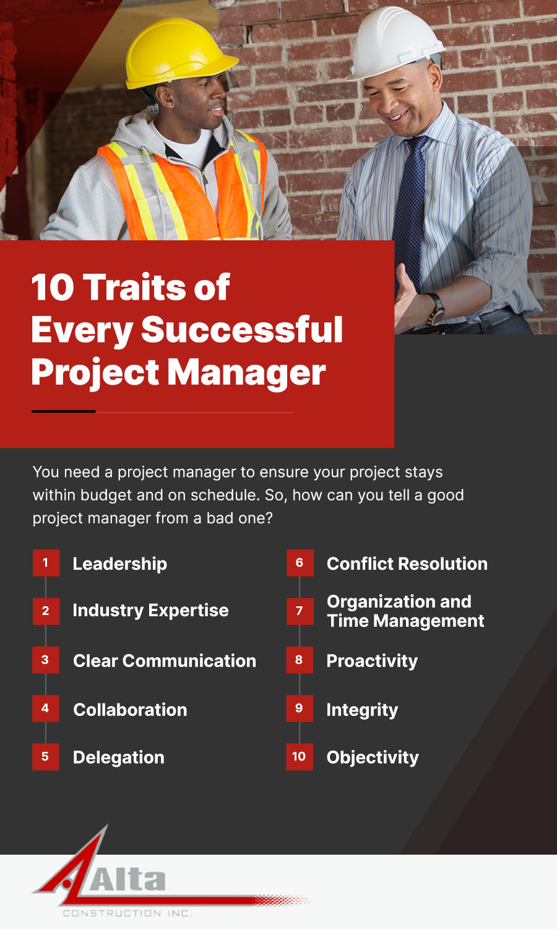



**Bonus 2:**

### ****What Is a Project Charter?**** A **Project Charter** is a brief, formal document that:

* **Authorizes** the start of the project
* **Defines** the project’s purpose, goals, and scope
* **Names** the Project Manager
* **Lists** the key stakeholders
* **Sets** the general timeline and budget
* **Gives** the project team the authority to begin working

### In Simple Terms: ✅ What are we doing? *✅* Why are we doing it? *✅* Who’s in charge? *✅* Who’s involved? *✅* What do we need to succeed?

## 📲 Ready to level up even more?

👉 Join our weekly speaking challenges  
👉 Ask about our IELTs practice, English for Explorers or Professional English according to your activity.  
👉 My English Hub – where your voice becomes powerful